Machine Learning Model 1: Time-Series Linear Regression for Gas Forecasting

1. Overview
To satisfy the time-series prediction requirement of the final project, we implemented two Multiple Linear Regression models using scikit-learn’s LinearRegression class to forecast Carbon Monoxide (CO) and Carbon Dioxide (CO₂) concentrations one hour ahead. Because the dataset was aggregated to hourly intervals during preprocessing, a one-hour prediction horizon was selected to preserve temporal consistency while still providing meaningful early-warning capability.

2. Methodology
Feature engineering incorporated lagged features (t−1, t−2, t−3), rolling mean and standard deviation (3-hour window), environmental variables (temperature, humidity), cross-sensor relationships, and motion-derived occupancy indicators.
The dataset was split chronologically (80/20) to prevent data leakage. StandardScaler was fit on training data only. Model performance was evaluated using MAE, RMSE, and R².

3. Results
CO Model Performance: MAE = 5.11, RMSE = 7.66, R² = 0.861
CO₂ Model Performance: MAE = 5.78, RMSE = 8.02, R² = 0.909
The models explain approximately 86% of CO variance and 91% of CO₂ variance during the test period, demonstrating strong predictive capability.

Figure 1. CO Concentration – Actual vs Predicted (1 Hour Ahead)
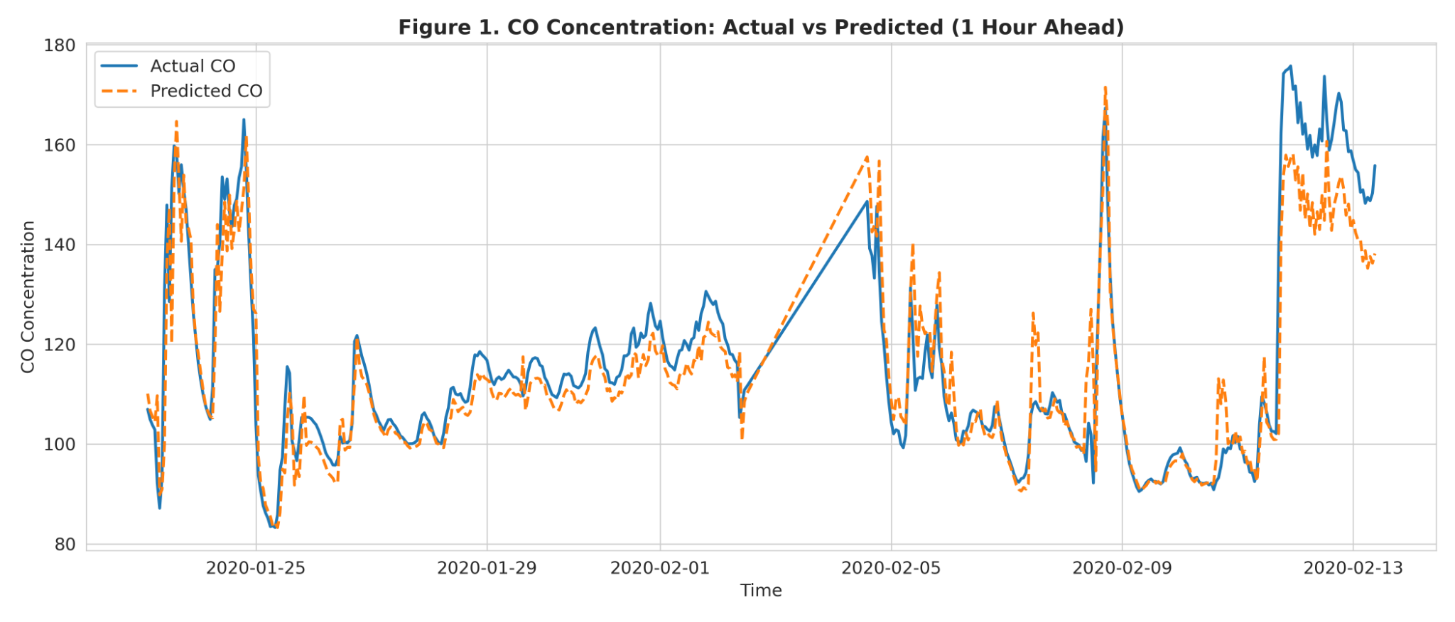

Figure 2. CO₂ Concentration – Actual vs Predicted (1 Hour Ahead)
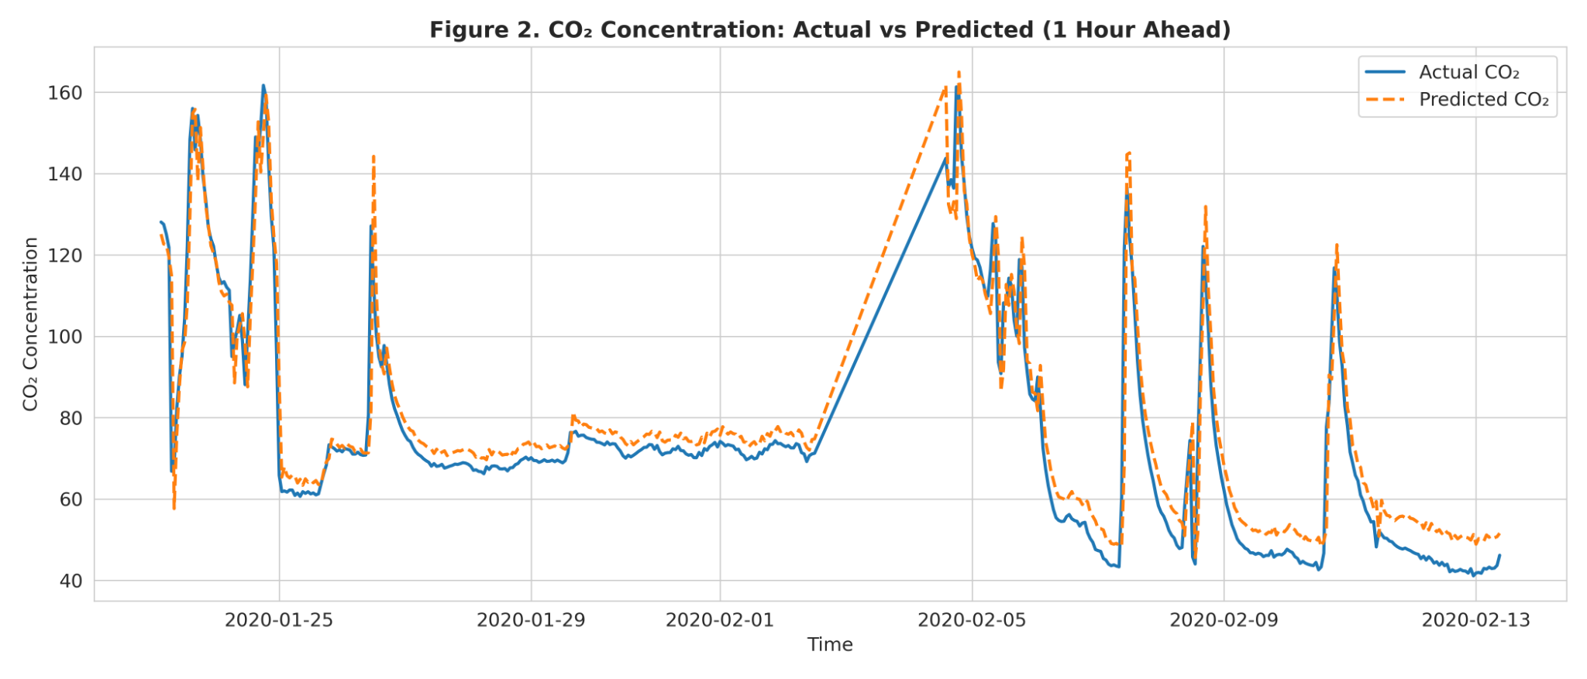

Figure 3. Linear Regression Coefficient Magnitudes (CO Model)
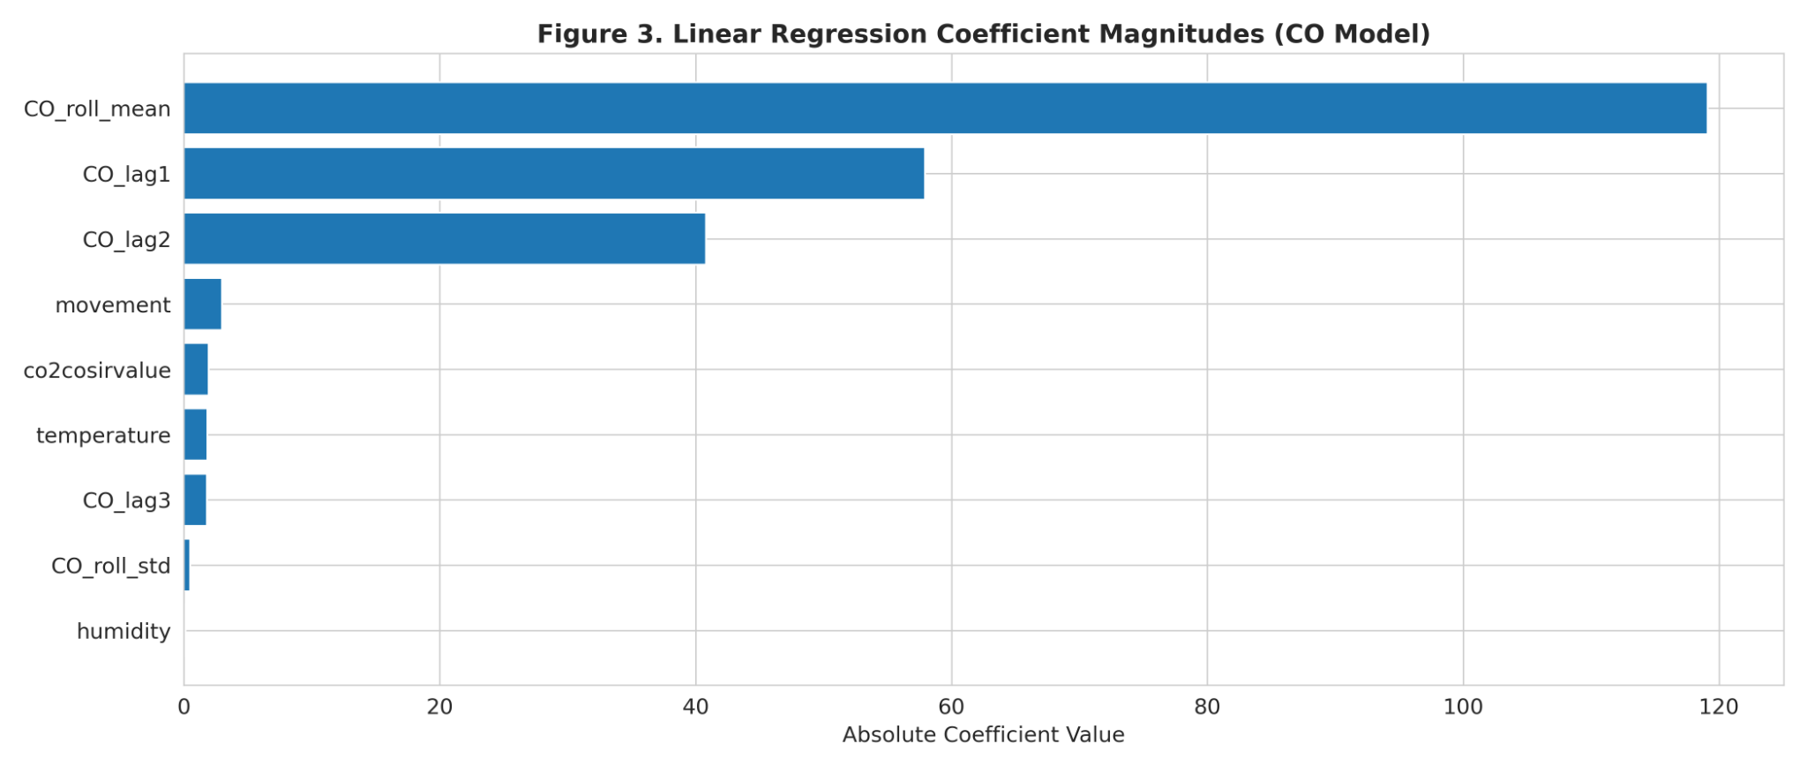

4. Discussion
Lag features and rolling statistics were the most influential predictors, confirming strong short-term autocorrelation in gas concentrations. The one-hour prediction horizon provides sufficient early-warning capability for proactive intervention in elder home monitoring systems.

5. Conclusion
The Linear Regression time-series models fulfill the project requirement for future prediction and demonstrate that traditional ML methods can achieve strong performance in IoT safety applications.

